**ECEN 350 Final Project: Power Supply with Current Limit**

**Scott Madeux**

**4/6/2019**

# Introduction

This project was to build a power supply that takes either AC or DC as an input (up to 21V) and converts it into 9V DC as an output. One of the features included on this power supply is an LED that turns on when the input voltage is at or above 14.5 volts. A second feature is that the output current is limited to prevent short-circuits and overheating of parts.

# Theory of Operation

**What is the purpose of diodes D1 and D2 along with capacitor Cf?**

Diodes D1 and D2 are there to rectify any AC voltage on the input. The diodes only allow current to pass in one direction in the circuit, turning any AC voltage into DC. Capacitor Cf is there to smooth out the DC signal going into the circuit. As the voltage rises on either In1 or In2, the capacitor is charged. As the voltage falls, the capacitor will resist the change in voltage by releasing some of its’ charge, hence keeping the voltage fairly steady.

**What is the purpose of diodes D3 and DZ1?**

Diode DZ1 is there to prevent any current from flowing through that part of the circuit while the input voltage is less than 12V. After that 12V breakout voltage is surpassed and current can flow through DZ1 and D3. The LED D3 will turn on once the voltage going into the circuit reaches a couple of volts above the 12V required for DZ1 (14.5V).

**What is the purpose** **of the LM385 Voltage Reference Diode and op-amp U1-A?**

The LM385 Zener Diode has a 2.5V breakdown voltage. This means that after the voltage on this reverse biased diode exceeds 2.5V, current is able to flow through it. Since the positive input of the op-amp is in parallel with this diode it will have the same voltage on it as does the LM385 (2.5V). The U1-A op-amp is used as a non-inverting amplifier to change the 2.5 volts coming into it to the 9 volts wanted on the output.

**How do resistor R5 and npn transistor Q1 together limit the current through M1 to the desired current limit value?**

When the drop over R5 becomes at least 0.65V, the transistor Q1 turns on. Since Q1Vbe remains a constant 0.65V and R5 is a constant resistance, the current in this part of the circuit must remain constant if the transistor Q1 is on. In this case since R5 is 3.9ohm, the current will max out at around 0.65V/3.9ohm or 167mA. Since the current cannot go higher than this limit, the output voltage must drop once the current limit is met. Once it is turned on, the transistor Q1 limits VGS of M1 so that VGS is such that ID is always 167mA.

**How does op-amp U1-B along with MOSFET M1 provide a regulated output voltage?**

When the output current is below the limit, the op-amp U1-B keeps VGS of the MOSFET M1 at a voltage were ID(Rload) = 9V. It does this because, as the load resistance increases, this causes Vout to increase, which is connected to the negative input on U1-B. Since we want both positive and negative inputs on the op-amp to be the same, the op-amp will adjust the output voltage going to the gate of M1 until there is enough current passing through M1 for Vout to be 9V and match the positive input of the op-amp.

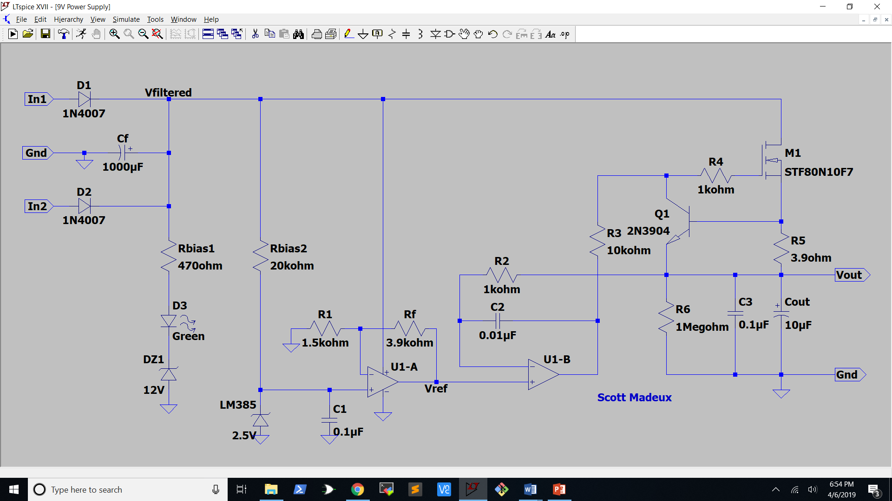

**Figure 1:** Schematic Diagram of the DC Power Supply

**Calculations:**

Current Limit

Tmax­ = 175˚C

Tamb­ = 50˚C

Thermal Resistance = 62.5 ˚C/W

VD = Vfilterd = 21V

VS = Vref = Vout = 9V

VDS = 21V – 9V – R5(IDmax)

= 12V – 0.65V = 11.35V

IDmax = (Tmax – Tamb)/ (Thermal Resistance)(VDS)

= (175˚C - 50˚C)/62.5˚C(11.35V)

= 176.2mA

R5 = 0.65V/176.2mA

= 3.689ohm

≈ 3.9ohm

Icalc = 0.65V/3.9ohm = 166.7mA

Rbias2

Imax_Rbias2 = 1mA

Vmax_Rbias2 = 18.5V

Rbias2 = 18.5V/1mA

= 18.5kohm ≈ 20kohm

Rf and R1

Av = Vo/Vi = (1 + Rf/R1)

9V/2.5V = 1 + (Rf/R1)

(Rf/R1) = 2.6

For op-amp output current of < 2mA:

(R1 + Rf) ≥ 9V/2mA

(R1 + Rf) ≥ 4.5kohm

V-U1-A = R1(Vref)/(R1 + Rf)

R1 = V-U1-A(R1 + Rf)/Vref

= 2.5V(4.5kohm)/9V

= 1250ohm ≈ 1.5kohm

Rf = (2.6)R1 = 3.9kohm

Filter Capacitor Cf

Cf = Icalc/(2fVripple)

= 0.1667A/(2(60Hz)1V)

= 1389.1667µF

≈ 1000µF

# Measured Performance

**Figure 2:** Output of voltage regulator as load current increases. Measured current limit: 158mA

**Table 2**: Measured Voltage Regulator Performance Parameters.

|  |  |
| --- | --- |
| **Parameter** | **Measured Values** |
| Measured Current Limit Value (mA). | 158mA |
| Percent error between measured and calculated current limit value, with % Error = (100)(Imeas – Icalc )/(Icalc). | -5.22% |
| Calculated input voltage ripple for 0.9Icalc. | 1.39V pk-pk |
| Measured input voltage ripple (∆Vfiltered) for the output loaded at approximately 90% of current limit (Vpk-pk). | 1.73V pk-pk |
| Measured output voltage for no external load. (V). | 8.823V |
| Measured output voltage for regulator loaded at approximately 90% of current limit. (V) | 8.724V |
| 120 Hz Ripple Rejection in dB at 90% of current limit. | 11.8 dB |
| DC input voltage which turns on your LED indicator (V). | 14.5V |

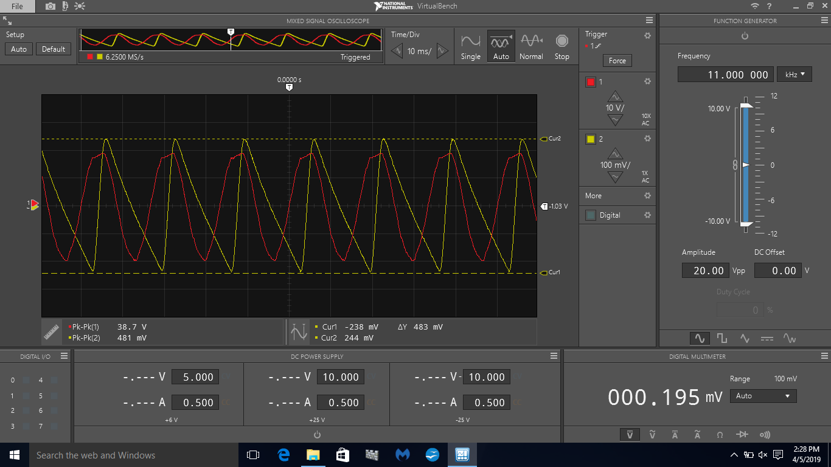

**Figure 3:** Output Voltage Ripple Measurement of a DC Power Supply. ∆Y = ∆Vout = 483mV

# Discussion and Conclusions

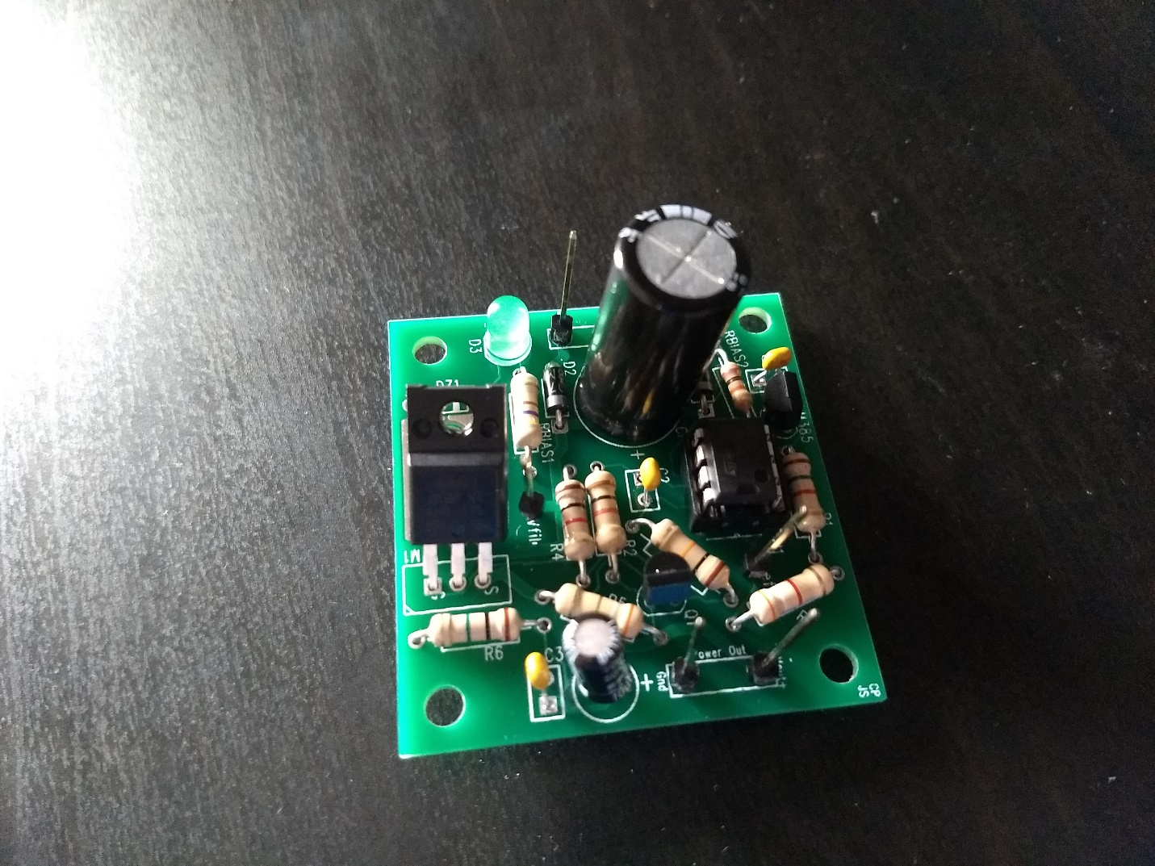

**Figure 4:** Photo of completed 9V power supply

I learned a lot over the course of this project about how lots of the things we learned about all work together. It was really great to revisit the current limiter and solidify in my mind how it works. I also enjoyed the chance to see some of the practical uses for op-amps and see how they can be both a good amplifier and a voltage regulator. In the future I would change things by taking a little more time make sense of everything before beginning to solder parts onto the PCB. I learned a lot as I built this circuit and tested it, but it would have been nice to have a complete idea of how everything works together ahead of time.

Note: If the ripple rejection looks a bit off that because it is. I accidentally connected an AC voltage source instead of an oscilloscope probe to a test point and I believe I fried either my LM385 or something else around the op-amp. One of my lessons learned would probably be to be more careful about which cable I’m connecting to which part of my board.